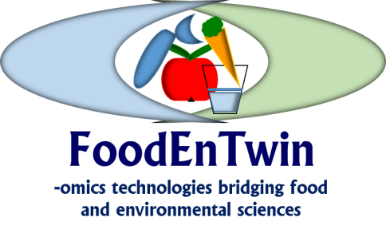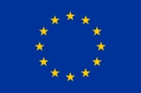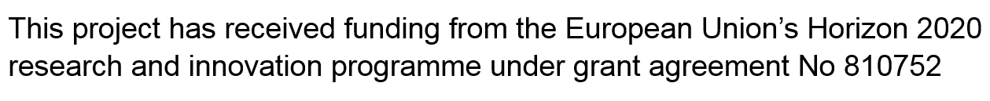

Twinning of research activities for the frontier research in the fields of food, nutrition and environmental ‘omics’ — FoodEnTwin

Registration form for the First FoodEnTwin workshop

Theme of the workshop: Food and Environmental –Omics
Date: 20 – 21 June 2019.
Venue: Belgrade, Serbian Academy of Sciences and Arts and University of Belgrade – Faculty of Chemistry
Organizers: FoodEnTwin consortium
Name of the applicant:
Institution and department:
PhD student: | Yes / No
Contact e-mail:
Contact address:
Registration with an abstract | Yes/No
Preferred presentation form: | Oral Poster
Application for the additional grant (accommodation for 2 nigths)# | Yes/No

Registration for the workshop is necessary but free of charge. The registration covers registration bag, lunches and refreshments.

This registration form and abstract (maximum 400 words) should be sent till May 31 by e-mail:
foodentwinwp3@chem.bg.ac.rs

The gala dinner will be organized on the 20 June, 2019. The cost of dinner is 25 EUR. The dinner can be paid in cash and the receipts will be given. Please check in the box if you plan to attend the dinner.
Yes ⁪
No ⁪

#Note: To the grant holders of the Metallomics summer school an additional grant to attend the workshop will be offered providing with an accepted abstract for the workshop. Grant will cover accommodation in Belgrade until June 22.

